

SubstrateX® Longitudinal Labs
Instrumenting Intelligence in Motion™

Longitudinal Computational Dynamics: Foundations of Computational Organization Across Extended Runtime

SubstrateX® Longitudinal Computational Dynamics Series ·
Paper 1 · Version 1.0 · October 2026

Author: Arjay Asadi
Position: Founding Architect, SubstrateX®
Affiliation: SubstrateX® Longitudinal Labs
Research: Longitudinal Computational Dynamics · Longitudinal Computational Behavior · Evidence-Governed Computation · Runtime Evidence Infrastructure
Correspondence: arjay.asadi@substratex.ai
Web: www.arjayasadi.com

© 2026 Arjay Asadi. All Rights Reserved.
Research Access: Non-Commercial Research & Intellectual Exchange Only.

Table of Content

0. Front Matter

Abstract
Computational systems are increasingly evaluated as if their behavior were exhausted by individual outputs, benchmark scores, or isolated incidents. That unit of analysis is inadequate for agents and other long-running systems whose behavior develops through accumulated context, tool use, role interaction, environmental feedback, correction, interruption, and recovery. This paper introduces Longitudinal Computational Dynamics as the scientific study of observable computational behavior across extended runtime. Its empirical object is Longitudinal Computational Behavior: the source-bound organization that becomes observable as computational activity forms, moves, recurs, drifts, stabilizes, enters regimes, crosses declared boundaries, collapses, recovers, or re-enters a supported operating condition through time.
The paper defines a runtime as an ordered, provenance-bearing evidence object rather than a hidden internal state. It formalizes runtime trajectories, evidence horizons, multiple temporal coordinate systems, anchors, drift, recurrence, continuity, regimes, boundary functions, Basin Exit, observable failure, recovery, and re-entry. It distinguishes computed organization from task performance, safety, correctness, causation, consciousness, and direct access to model internals. It also introduces Evidence-Governed Computation as the architectural discipline required to keep measurements, interpretations, and preserved artifacts subordinate to the source and declared methods that authorize them.
The resulting scientific program connects dynamical systems, change-point detection, process mining, provenance, observability, resilience engineering, and agent-trajectory analysis while addressing a different question: What kind of computational organization developed through time? The paper states falsifiable propositions, a validation ladder, minimum reporting requirements, and an agenda for cross-system and prospective research. SubstrateX Aperture is presented as a reference implementation that demonstrates executability.
Within its declared controlled validation scope, the implementation has established deterministic reproduction of governed evidence records and has shown that selected runtime measurements distinguish known transition cases from stable and negative controls better than simple baselines. Those results establish an implemented and testable foundation; external validity, construct calibration, predictive performance, and independent replication remain separate scientific questions.
Keywords: longitudinal computational dynamics; computational behavior; AI agents; runtime evidence; trajectory analysis; regime transition; boundary formation; drift; recovery; provenance; observability; evidence-governed computation
01. Introduction
The behavior of a long-running computational system is rarely contained in its final output. An agent may satisfy a task while gradually abandoning an important constraint. A multi-agent workflow may remain locally fluent while role coordination deteriorates. A tool-using system may enter a repetitive loop, correct one step, and then return to the same pattern. A visible failure may occur only after a prolonged interval of weakening, recurrence, drift, or increasing interaction pressure. Conversely, a system may survive substantial disturbance and establish a revised but coherent operating pattern.
These phenomena are longitudinal. They concern relations among events across a runtime rather than the quality of one response. Endpoint evaluation and aggregate success metrics remain useful, but they cannot by themselves establish how behavior formed, whether an apparent anomaly persisted, when a transition became observable, or whether recovery was sustained.
Longitudinal Computational Dynamics, abbreviated LCD, is proposed as the scientific field devoted to these questions. It studies observable computational organization across extended runtime through source-bound records and declared measurement methods. Its scope includes trajectories, temporal relationships, recurrence, drift, stability, regimes, boundary formation, collapse, recovery, and re-entry. LCD does not treat these observations as direct access to hidden model state. It studies the organization supported by the record.
The field is organized around a change in the unit of analysis. Conventional evaluation often asks whether an output is correct, safe, helpful, or successful. LCD asks:
What kind of computational organization developed through time?
That question becomes more consequential as agents operate across longer horizons, retain or reconstruct context, invoke tools, coordinate with other agents and people, affect external systems, and participate in workflows whose failures form gradually. Recent research has begun to analyze agent execution trajectories, process variability, long-horizon profiling, provenance, and explicit runtime state [6-10]. These efforts establish the importance of trajectory-level observation. They do not yet provide a shared scientific object that unifies formation, motion, regimes, boundary events, recovery, evidence authority, and claim limits.
LCD is an integrative proposal. Dynamical systems theory supplies concepts for trajectories, attractors, stability, and transitions [1]. Change-point detection provides methods for locating structural change [4]. Process mining reconstructs and evaluates processes from event logs [5]. Observability systems collect traces, metrics, and logs [12]. Provenance standards formalize how entities and activities are derived [11]. Resilience and cognitive systems engineering examine adaptation in complex human-machine work [14]. LCD combines relevant ideas from these areas around a narrower empirical target: the observable organization of computational behavior as it develops through runtime.
This paper makes six contributions.
1. It defines LCD as a scientific field and Longitudinal Computational Behavior as its empirical object.
2. It provides a formal representation of source-bound runtime trajectories and evidence horizons.
3. It defines a common scientific vocabulary for motion, drift, recurrence, continuity, regimes, boundary formation, collapse, recovery, and re-entry.
4. It establishes epistemic and claim boundaries that separate observable runtime evidence from hidden-state, causal, normative, and anthropomorphic claims.
5. It specifies a falsifiable research program and minimum reporting standard.
6. It identifies Evidence-Governed Computation as the architectural discipline that makes longitudinal findings traceable, reproducible, and preservable.
The hierarchy is therefore:
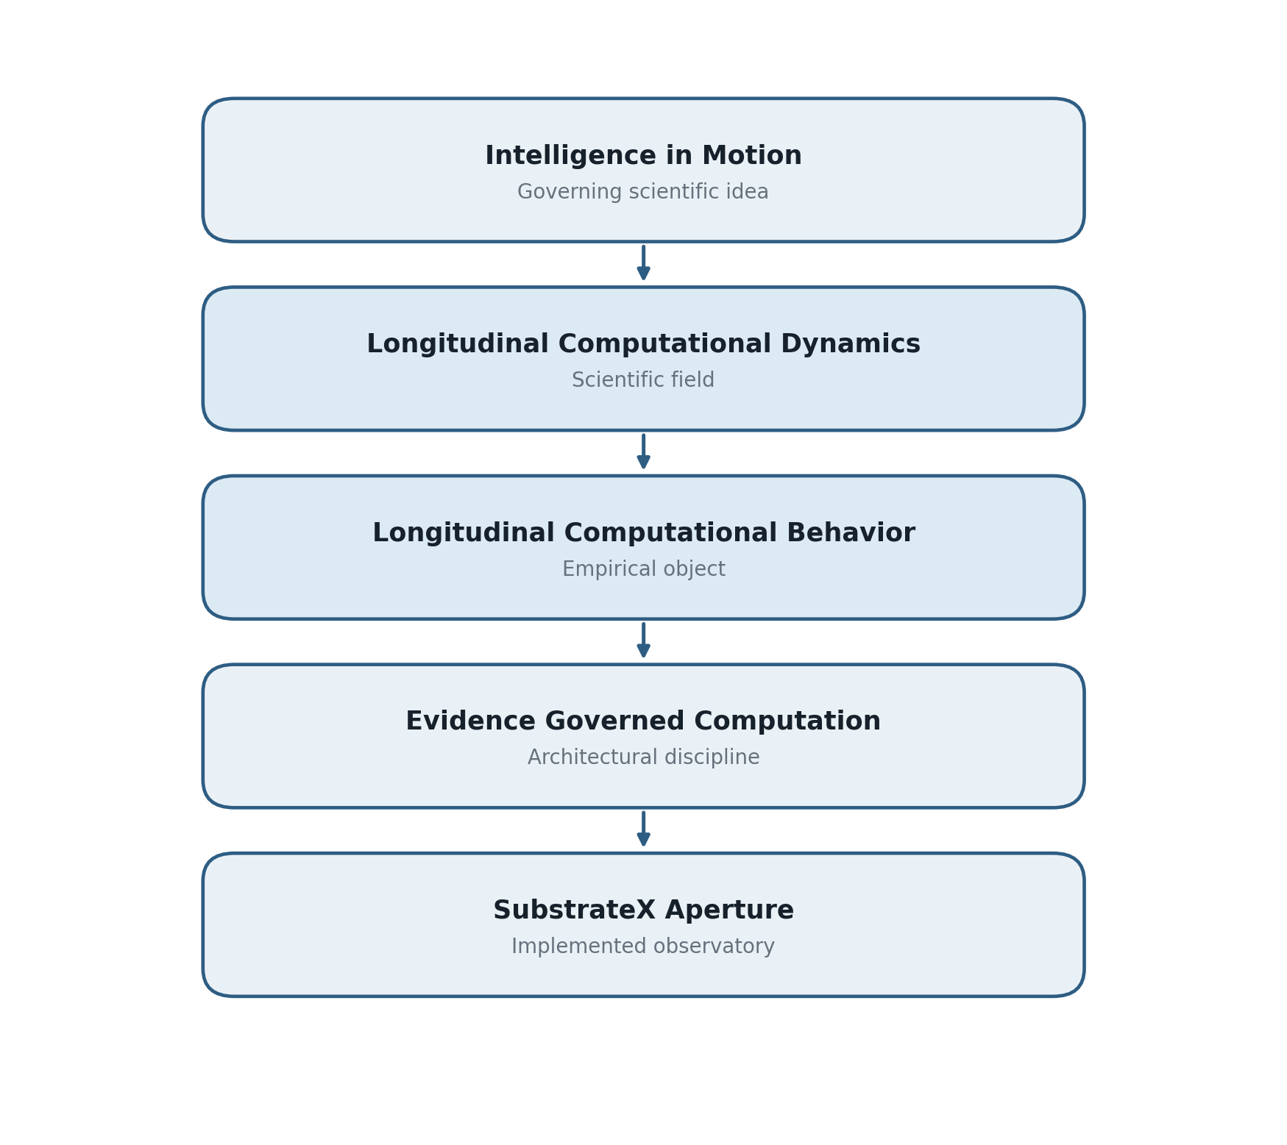
Figure 1. Scientific hierarchy from governing idea to reference implementation
The hierarchy prevents the field from being confused with its instrument. Aperture implements one evidence architecture for LCD. It does not define the limits of the field, and its existence does not validate every LCD construct by itself.

02. The Missing Scientific Object
Long-running computational behavior is presently distributed across several analytical traditions. Software observability records operational state. Process mining discovers sequences and checks conformance. Agent benchmarks score outcomes. Interpretability research examines model representations or internal activations. Safety evaluations test specified behaviors. Human factors studies interaction among people and machines. Each contributes necessary methods, but none alone treats observable computational organization across runtime as the primary empirical object.
This gap matters because the same endpoint can arise through different trajectories. A successful task may follow a stable path, an unstable path with late correction, or a collapse-and-recovery sequence. A failed task may reflect immediate incapability, gradual drift, role conflict, tool recursion, or a missing external dependency. Endpoint equivalence therefore does not imply dynamical equivalence.
The reverse also holds. Similar trajectories may lead to different outcomes because an external intervention, resource limit, user correction, or tool result changes the final state. A trajectory-level science must preserve the difference between the development of computational organization and the operational consequence attached to it.
LCD defines the missing object as Longitudinal Computational Behavior. LCB is the observable organization of computational activity across an ordered runtime, including the relations among events, roles, outputs, tools, constraints, markers, and derived measurements. It is not identical to the raw log. A log contains records. LCB is the source-bound structure that can be reconstructed from those records under declared methods.
LCB is also not identical to an internal state trajectory. A language model, agent controller, orchestrator, human operator, and external environment may each contain states that are not recorded. LCD can use internal traces when they are supplied and qualified, but it does not infer their existence from output geometry alone. The object remains what the evidence supports.

Scope and Foundational Definitions

Runtime
A runtime is a bounded interval of computational activity represented by an ordered set of source-linked events and their admissible relationships. A runtime may be a conversation, agent execution, multi-agent episode, incident response, software workflow, tool-mediated task, continuous service interval, or another computational process with sufficient ordering and provenance.
The boundary of a runtime must be declared. It may be determined by a case identifier, session, workflow, incident window, source collection rule, or experimental protocol. Changing the runtime boundary can change the evidence object and must therefore remain visible.

Computational organization
Computational organization is the evidence-supported structure formed by relations among runtime elements. It may include continuity of objectives, constraint retention, recurrence of symbolic patterns, role coordination, tool-use structure, temporal coupling, behavioral coherence, drift relative to an anchor, and transition among measured regimes.
Organization is relational. It is not reducible to one token, event, metric, or score. It can persist while surface wording changes, and surface repetition can occur without preserving organization.

Longitudinal Computational Behavior
Longitudinal Computational Behavior is the empirical pattern of computational organization observable across a runtime through qualified source records, canonical ordering, declared measurements, and explicit evidence limits.
This definition imposes four conditions.
- Longitudinal: the object requires ordered relationships across more than one runtime position.
- Computational: the activity is produced or mediated by executable systems, including interactions with people and tools when they are part of the recorded runtime.
- Behavioral: the object concerns observable activity and its organization, not an assumed private mental state.
- Evidence-bound: every material finding must resolve to a source basis, method, evidence horizon, and claim boundary.

Longitudinal Computational Dynamics
Longitudinal Computational Dynamics is the scientific study of observable computational behavior across extended runtime. It examines trajectories, temporal relationships, recurrence, drift, stability, regimes, boundary formation, collapse, recovery, and re-entry through source-bound records and declared measurement methods, without treating those observations as direct access to hidden internal state.
LCD is substrate-neutral. It can study language-model agents, multi-agent systems, classical software workflows, human-AI operations, autonomous services, or hybrid systems when the record supports a runtime reconstruction. It is not restricted to natural-language data, although language is presently a major source of observable behavior.

Runtime Evidence Model

Source qualification and canonicalization
Let a supplied source record be denoted by S. The source includes the recorded content together with available source metadata. A qualification function Qᵥ, governed by version v, evaluates whether S can support canonical reconstruction and returns a qualification state, coverage record, warnings, and adapter decision:

Canonicalization applies a declared method Cᵥ to the qualified source:

The canonical runtime R contains an ordered event sequence

where each event may include an identifier, source span, role, event family, coordinates, content reference, adapter provenance, and missingness state. Canonicalization can normalize structure. It cannot create source facts.

Temporal coordinates
No single coordinate system is sufficient for every runtime. An event may therefore carry a coordinate vector

where the available components may represent frame position, canonical turn, source turn, event order, wall-clock time, dependency order, and symbolic time. Unavailable coordinates remain unavailable.
Wall-clock time measures elapsed physical time when reliable timestamps exist. Event and turn coordinates preserve ordering. Dependency coordinates represent causal or procedural precedence supplied by the record. Symbolic time is a computed coordinate describing accumulated behavioral change, recurrence, or event density under a declared method. Symbolic time is not subjective experience or hidden time inside a model.

Evidence horizons
For runtime position k, the admissible evidence horizon is

where ≼ is the declared ordering relation. A prospective finding issued at k may use only Hₖ. A retrospective reconstruction may use later evidence, but it must be labeled retrospective.
This distinction is necessary to prevent temporal leakage. A method that identifies a transition after observing the entire runtime cannot be described as an advance warning at the original transition point unless the same finding can be reproduced using only the evidence available then.

Observable runtime state
A versioned feature map Fᵥ transforms the admissible horizon into an observable runtime state:

The vector xₖ ∈ ℝᵖ, or a structured non-Euclidean equivalent, may contain direct features, derived measurements, relational quantities, availability flags, and uncertainty. It is an analytical representation of the record. It is not the full physical or computational state of the system.
The runtime trajectory is

where πₖ is the provenance mapping that links each state component to its source spans, dependencies, and method version.

Evidence classes
LCD distinguishes at least four evidence classes.
Table 1. Evidence classes used in Longitudinal Computational Dynamics.
Evidence class | Description | Example
Observed | Present directly in the qualified record | Timestamp, tool call, source role label
Computed | Deterministically derived by a declared method | Entropy estimate, recurrence value, regime interval
Projected | Higher-order representation built from authorized observations and computations | Worldline geometry, basin proximity, recovery posture
Interpreted | Versioned classification or human-readable synthesis | Incident posture, investigation route

The class does not rank importance. It states how the item obtained authority. A projected value cannot be presented as if it were directly observed, and an interpretation cannot rewrite the computation it summarizes.

Formation and Continuity
Computational organization must form before it can move or destabilize. Formation is the development of a repeatable relation among runtime elements. It may begin with an objective, role structure, vocabulary, constraint set, procedural pattern, interaction protocol, or reference condition.
An anchor A is a declared reference derived from an eligible source interval or supplied external specification. Examples include an initial instruction set, a stable baseline window, an approved plan, a role contract, or a canonical task state. Anchor provenance is essential because drift has no meaning without a reference.
Continuity is the degree to which later runtime organization remains related to earlier organization under the declared measures. Continuity can survive surface change. A system may rephrase an objective while preserving its constraints. It can also imitate continuity through repeated language while changing the operational relation among roles, tools, or goals.
Recurrence is the return of a measured structure after an interval. Let Wᵢ and Wⱼ be two runtime windows. A recurrence function may be written as

High recurrence can indicate stable continuity, productive reuse, rigid repetition, or lock-in. Its meaning depends on accompanying signals and the operational context. Recurrence alone is not evidence of memory, identity, cognition, or beneficial coherence.
Formation may be studied as a sequence of observable states such as initial anchoring, echo, modulation, reflection-like structure, re-anchoring, and looping. These labels classify patterns in the record. They do not assert hidden cognitive stages.

Motion and Drift

Runtime motion
Runtime motion describes change in observable organization between eligible positions. The simplest displacement is

When a meaningful scalar coordinate exists, a local rate can be estimated as

In many runtimes, event spacing is irregular and feature spaces are mixed. LCD therefore does not require Euclidean velocity. Motion may be represented through graph distance, semantic distance, distributional change, transition operators, or other versioned relations.

Drift
Drift is cumulative displacement relative to a declared anchor or supported reference trajectory. For a distance function dᵥ, anchor-relative drift is

Drift may concern objectives, constraints, roles, semantics, procedure, tool selection, temporal structure, or a multivariate combination. A rising drift value does not automatically mean degradation. Adaptation can require departure from an initial plan. The scientific question is whether the departure is supported, persistent, reversible, and operationally relevant.
Drift analysis should therefore report direction, magnitude, persistence, anchor choice, and evidence basis. A point estimate without these properties is insufficient.

Curvature and path dependence
Two runtimes can end at the same state after following different paths. Path dependence can be represented through curvature, accumulated distance, recurrence structure, or state-transition history. A trajectory that departs and returns is not equivalent to one that remained near the anchor, even when their final states coincide.
LCD treats this path information as scientifically relevant. It can reveal intervention, oscillation, repeated correction, hysteresis, or hidden dependence on earlier events. The representation still concerns observable relations; it does not establish a hidden physical manifold.

Stability and Regimes

Runtime stability
Runtime stability is the persistence of an evidence-supported organizational condition under the disturbances represented in the record. It can involve bounded drift, maintained constraint relations, coherent role coordination, recoverable response to perturbation, or persistence within a declared region of feature space.
Stability is not synonymous with correctness, safety, alignment, truth, or successful task completion. A system can stably repeat an error. It can also behave usefully while undergoing a legitimate transition.

Regime definition
A runtime regime is a persistent interval whose measured organization is sufficiently distinct from adjacent intervals under a declared classification method. Let

denote the regime label at position k. A regime interval is a maximal contiguous set of positions that satisfies the method's persistence and hysteresis rules.
LCD proposes a general five-regime vocabulary. Implementations may use different names or add domain-specific regimes when their contracts are explicit.
Table 2. General runtime regime vocabulary and claim limits.
Regime | Evidence supported meaning | What the label does not establish
Stable | Organization remains within declared stability conditions for the required persistence interval | Correctness, safety, or absence of hidden change
Transitional | Persistent movement occurs between supported organizations or stability conditions | Failure or inevitable collapse
Phase locked | Recurrence or coupling constrains the trajectory into a persistent formation | Beneficial coordination, cognition, or a physical attractor
Collapse | A previously supported organization loses required continuity or stability across a sustained interval | Real-world harm, unique cause, or irreversible failure
Recovery | Organization is sustained after disturbance under declared recovery criteria | Return to an identical prior state or permanent success

Persistence and hysteresis
Point thresholds are vulnerable to noise. A regime method should normally require persistence across multiple eligible positions or a declared duration. Entry and exit criteria may differ to prevent rapid oscillation around a boundary. This hysteresis is methodological, not evidence of a physical mechanism.
A regime assignment should preserve uncertainty when evidence is incomplete. Short records, irregular sampling, missing roles, or absent timestamps may make a regime partial or unavailable. An unavailable regime cannot be converted into stable by default.

Boundary Formation and Basin Exit

Declared boundaries
A runtime boundary is a versioned decision surface separating two evidence-defined organizational conditions. Let gᵥ be a boundary function such that

denotes the supported side of a declared stability region and

denotes a crossing condition. The boundary may be rule-based, statistically estimated, learned from labeled data, or derived from a calibrated reference distribution. Its construction and validation status must be reported.

Candidate and confirmed crossings
A candidate boundary event is the first admissible observation that satisfies the crossing predicate but has not yet met persistence, coverage, or corroboration requirements.
A confirmed boundary event satisfies both the crossing predicate and the declared confirmation rule Pᵥ. The confirmed Basin Exit coordinate is

In LCD, Basin Exit is a term for a confirmed crossing of a declared observable stability boundary. It is not proof that the underlying model contains a literal physical basin or that an inaccessible internal state crossed a known manifold.

Boundary formation as a process
Boundary events often form through an interval rather than appearing without precursor structure. LCD distinguishes:
1. first observable weakening;
2. candidate boundary formation;
3. confirmed boundary crossing;
4. post-exit development;
5. observable failure, recovery, or continued transition.
The sequence is an evidentiary grammar, not a universal law. Some runtimes may fail abruptly without observable weakening. Others may cross a measurement boundary and recover without operational failure. A valid method must preserve both cases.
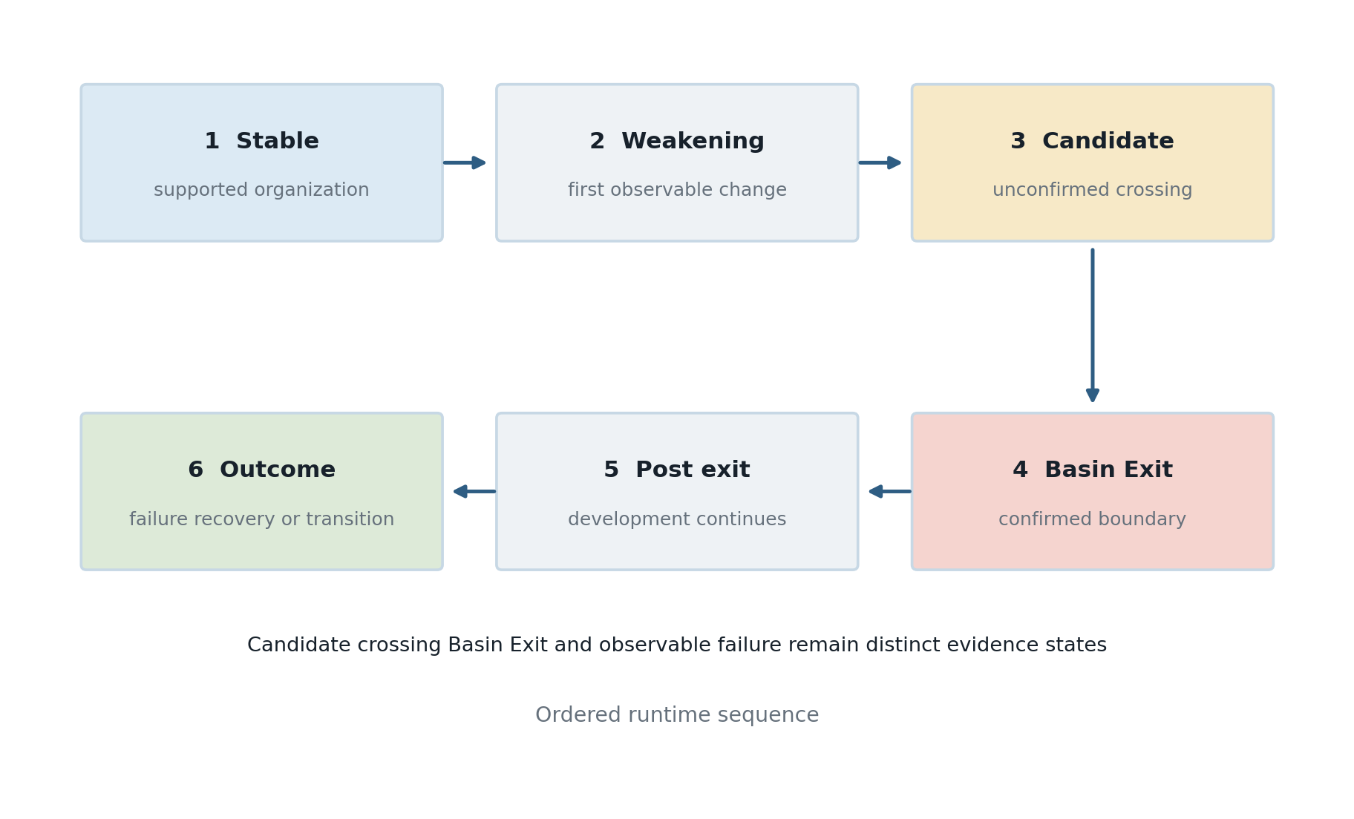
Figure 3. Evidence states in a general boundary formation sequence.

Failure and lead time
An observable failure coordinate is separate from Basin Exit. It must be supplied by the source or computed under an independently declared failure rule. If the Basin Exit coordinate and failure coordinate are both admissible in a shared coordinate system, and Basin Exit precedes failure, formal lead time is

If no observable failure coordinate is available, the interval after Basin Exit is an open warning window or post-exit observation period. It is not formal lead time. If Basin Exit was located retrospectively using evidence after failure, it cannot be reported as prospective warning without a leakage-free re-evaluation.

Collapse Recovery and Reentry

Collapse
Collapse is the sustained loss of an organization that the declared method previously supported. The lost property may be continuity, constraint retention, coordination, temporal coherence, task structure, or another registered construct. Collapse must therefore name what collapsed and under which method.
Collapse does not automatically mean system shutdown, incorrect output, safety incident, or material harm. Those outcomes require separate evidence. The term describes a runtime organization relative to a declared reference.

Correction and recovery
A local correction is a change in one event or response. Recovery is a sustained runtime property. A recovery finding should normally require evidence of:
- re-entry into declared stability conditions or entry into a new supported regime;
- restoration or reorganization of relevant continuity;
- persistence across a required horizon;
- reduction or resolution of the measurements that supported the earlier disturbance; and
- absence of immediate relapse within the available evidence window.
Let Sᵥ denote the applicable stability set and L the minimum persistence horizon. A simple re-entry rule is

More general methods can allow a revised stable organization rather than a return to the original anchor.

Reentry and transformation
Re-entry is the evidence-supported return from a boundary departure into an admissible stability region. Recovery is broader: the system may reorganize into a different supported regime. A recovered runtime need not reproduce its original state. It must satisfy the declared criteria for sustained organization.
This distinction is important in adaptive systems. A change can be both a departure from the original configuration and a successful response to new evidence. LCD should not classify adaptation as failure merely because the endpoint differs from the starting point.

Evidence Governed Computation
Longitudinal analysis creates a risk of interpretive inflation. A derived score may be presented as an observation, a geometric projection as hidden state, a retrospective boundary as prediction, or an association as cause. Evidence-Governed Computation addresses this problem by making the authority of every computational claim explicit.
A material claim can be represented as

where p is the proposition, r is the runtime identity, B is the evidence basis, m is the method and version, h is the evidence horizon, s is the evidence status, and ℓ is the claim limit.
A claim is admissible only when its required dependencies exist, its method is authorized for the evidence class, its temporal horizon is valid, its missingness state is preserved, and its language remains within the declared claim boundary. This can be expressed as an admissibility predicate

only when all applicable conditions are satisfied.
This architecture extends established provenance principles. W3C PROV identifies entities, activities, derivations, agents, and the provenance of provenance [11]. LCD requires those lineage concepts and adds measurement legitimacy, temporal admissibility, claim-specific limits, and continuity of evidence authority across runtime reconstruction, instrumentation, interpretation, and preservation.

Missingness
Missingness is part of the evidence state. LCD distinguishes, at minimum, not observed, not supplied, not computable, insufficient horizon, unavailable dependency, outside scope, and experimentally unsupported. These states are not interchangeable.
A missing value must not silently become zero. A missing failure marker does not establish no failure. An unavailable signal does not support stability. A short post-event horizon does not support sustained recovery.

Claim boundary
LCD measurements do not independently establish:
- hidden model state or private reasoning;
- consciousness, cognition, agency, selfhood, or subjective experience;
- intent, deception, blame, competence, or legal responsibility;
- objective truth or unique causation;
- universal safety, alignment, readiness, or compliance;
- calibrated probability without separate calibration; or
- future failure without prospective validation.
These exclusions do not make LCD weak. They make its empirical claims testable.

Reference Implementation in SubstrateX Aperture
SubstrateX Aperture is a Runtime Evidence Observatory that operationalizes the LCD evidence path. It is a reference implementation, not the field itself.
The implementation follows this general sequence:
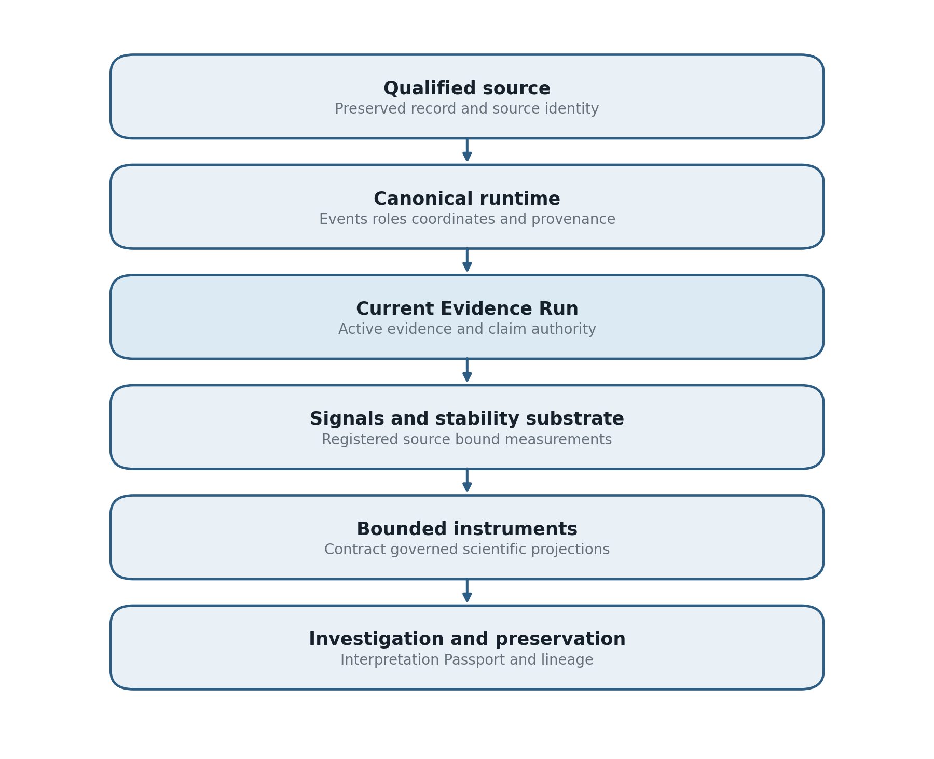
Figure 2. Evidence path implemented by the SubstrateX Aperture reference architecture.
The Current Evidence Run is the active authority that connects source identity, canonical runtime structure, temporal coordinates, registered measurements, markers, missingness, and claim boundaries. A Runtime Evidence Passport identifies the evidence object, its governing versions, provenance, disclosure state, integrity posture, certification scope, non-certifications, and preservation lineage.
Aperture exposes the same runtime through nine contract-governed instruments: Seismo, Chronos, Drift, Pressure, Bridge, Noesis, Scope, Dynamics, and Interferometer. The instruments examine different properties of the record, but they cannot create separate runtimes, rewrite canonical events, move authoritative markers, or expand the claim boundary. The Runtime Evidence Interpretation Matrix operates above measurement as a versioned classification and investigation-routing layer. Human-readable synthesis remains a derived projection.
This implementation demonstrates that an LCD architecture can be executable, inspectable, versioned, replayable, and preservable. Its components are hypotheses and methods open to scientific evaluation. Product completeness is not evidence of construct validity.

Current Validation Status
Scientific maturity must be stated by proposition. The present LCD and Aperture program has established two results within its declared controlled validation scope.

Deterministic evidence reproduction
The computational proposition has been confirmed: the same qualified source, canonicalization method, configuration, and governing versions reproduce the same deterministic evidence record. Variable envelope fields such as issuance time or operator-declared context are kept separate from the governed evidentiary core.
This result establishes computational reproducibility for the tested implementation and fixtures. It does not establish that the source is true, that every metric is valid, or that independently developed implementations will produce equivalent constructs.

Discrimination of transition cases
The scientific proposition has also been confirmed within the current known-scenario validation program: selected runtime measurements distinguish known transition cases from stable and negative controls better than simple baselines.
This result is stronger than an implementation demonstration because it tests discriminative behavior against controls. Its scope remains bounded by the cases, labels, source families, measurement versions, and baselines included in the declared validation program. Publication of the full empirical result requires the accompanying fixtures, sample definitions, numerical results, baseline specifications, uncertainty estimates, ablations, and release hashes. The foundational paper does not invent those statistics or generalize beyond them.

Validation ladder
LCD separates five maturity states.
Table 3. Scientific maturity and validation ladder.
State | What it establishes
Defined | The construct has an explicit semantic and measurement contract
Implemented | Executable code instantiates the declared method
Deterministic | Repeated eligible computation reproduces governed outputs within tolerance
Validated | Controlled evidence supports a specified scientific proposition
Independently replicated | An unaffiliated party reproduces the specified result from released materials

The first four states can apply to the two propositions above within their declared scope. Independent replication remains a separate milestone. Cross-domain generalization, prospective warning, calibrated operational prediction, and causal attribution also require separate studies.

Relationship to Adjacent Fields
LCD is neither a replacement for established fields nor a renamed form of one of them. Its contribution is the integration of their relevant methods around a distinct empirical object and evidence contract.
Table 4. Relationship between Longitudinal Computational Dynamics and adjacent fields.
Adjacent field | Primary concern | Relationship to LCD | Distinction
Dynamical systems | Evolution of state under governing rules | Supplies concepts for trajectories, stability, attractors, and transitions [1] | LCD often observes partial, heterogeneous records rather than a known physical state and governing equation
Change point detection | Locating statistical distribution changes | Supplies boundary and segmentation methods [4] | LCD also studies formation, regimes, role structure, recovery, provenance, and claim admissibility
Process mining | Discovering and checking processes from event logs | Supplies event-log reconstruction and conformance methods [5] | LCD centers behavioral organization and cross-signal runtime dynamics rather than process structure alone
Software observability | Collecting and correlating traces, metrics, and logs | Supplies instrumentation and context propagation [12] | LCD qualifies evidence and tests scientific constructs over reconstructed runtimes
Provenance research | Recording derivation and lineage | Supplies models for entities, activities, and derivations [11] | LCD binds provenance to measurement legitimacy, temporal horizons, and claim limits
Agent evaluation | Measuring task success, capability, safety, or cost | Supplies tasks, outcomes, and trajectory records | LCD treats the development of organization as a separate object from endpoint performance
Interpretability | Explaining models or internal representations | Can provide additional evidence channels | LCD does not require or imply access to hidden activations or internal reasoning
Resilience and cognitive systems engineering | Adaptation and control in complex joint systems | Supplies concepts for coping, coordination, and recovery [14] | LCD specifies source-bound computational trajectories and machine-readable evidence contracts

Recent agent research supports the need for the field. Process observability has been applied to behavioral variability in agent execution [6]. Code-agent studies find that successful and failed trajectories differ in length, variance, strategy, and modification behavior [7]. Long-horizon profiling research argues that per-execution tracing is inadequate for tasks that span days or weeks [8]. Runtime-ledger work shows that explicit execution state can improve long-horizon coding-agent performance and cost [9]. PROV-AGENT extends provenance models to capture agent interactions across workflows [10]. These contributions are complementary. LCD supplies a general ontology and evidence discipline for studying the behavior represented by such records.

Falsifiable Scientific Propositions
LCD should advance through propositions that can fail. The following hypotheses define an initial research program.

Longitudinal sufficiency
Trajectory features should distinguish specified runtime conditions better than endpoint-only or unordered aggregate baselines when temporal organization is genuinely relevant. Failure to outperform those baselines would show that the longitudinal representation adds no value for that construct.

Persistence advantage
Persistence and hysteresis rules should reduce false transition detections relative to single-point thresholds without making detection unacceptably late. This can be tested on stable controls, perturbation cases, and boundary-adjacent noise.

Cross-signal coherence
Transitions supported by multiple conditionally independent measurements should be more reliable than transitions inferred from one dramatic metric. Ablation studies should determine whether each signal adds discriminative information or merely duplicates another.

Boundary and failure separation
A valid boundary method should identify cases in which Basin Exit occurs without observable failure and cases in which failure occurs without an admissible advance boundary. If every boundary is defined only by the failure it purports to precede, the method is circular.

Recovery persistence
Sustained recovery criteria should distinguish durable reorganization from local correction better than a one-event recovery label. This requires sufficient post-intervention horizon and explicit relapse tests.

Role topology contribution
In multi-role runtimes, role and handoff measurements should add explanatory or predictive value beyond content-only baselines when coordination is part of the mechanism under study. If they do not, role topology should not be retained for that class of cases.

Source-family transport
A construct claimed to be source-family independent should maintain meaning and acceptable performance across qualified source families after adapter and coverage effects are controlled. Large performance loss would restrict the construct's scope.

Governance effectiveness
Evidence-governed synthesis should reduce unsupported or temporally inadmissible claims compared with unconstrained summarization. This can be measured through blinded review of claim accuracy, traceability, missingness preservation, and leakage.

Experimental Program

Case structure
An LCD study should include stable controls, transition cases, negative controls, ambiguous cases, and records with intentionally missing evidence. When possible, cases should be held out from threshold selection. Source-family, model, agent architecture, task type, runtime length, and operational context should be varied independently enough to detect confounding.

Baselines
Every proposed runtime measurement should be compared with simple baselines appropriate to its claim. Examples include endpoint score, cumulative error count, moving average, event frequency, sequence length, generic change-point detector, or task outcome. A complex LCD construct has little scientific value if a simpler method performs equally well under the same evidence horizon.

Prospective evaluation
Prospective warning claims require a frozen detector, a declared evidence horizon, held-out cases, and independently qualified outcome markers. Thresholds must be chosen without access to future test outcomes. Evaluation should report detection rate, false alerts, missed events, time-to-detection, lead-time distribution, and calibration where probabilities are claimed.

Ablation and perturbation
Ablation should remove signals, roles, source fields, and temporal coordinates to determine which dependencies are necessary. Perturbation tests should vary event order, duplicate events, alter non-substantive wording, remove timestamps, and introduce adapter ambiguity. A scientifically useful method should identify the changes to which it is intended to be sensitive and remain stable to irrelevant perturbations.

Replication
Replication requires source-bound fixtures or lawful equivalents, canonicalization contracts, schemas, executable versions, dependency manifests, expected outputs, tolerance rules, and discrepancy classifications. Screenshots and narrative case descriptions are not replication packages.

Minimum Reporting Standard
Every published LCD result should disclose enough information to reconstruct the authority of the finding.
Table 5. Minimum reporting requirements for a published LCD result.
Reporting element | Minimum disclosure
Runtime scope | Start and end rule, case identity, inclusion and exclusion criteria
Source | Source family, provenance, permitted use, raw or content hash where appropriate
Qualification | Coverage, adapter, warnings, ambiguity, excluded material
Canonicalization | Method and version, role and event mappings, ordering rules
Coordinates | Event, turn, clock, dependency, or symbolic coordinate definitions
Evidence horizon | Prospective or retrospective status and allowed future information
Measurements | Definitions, parameters, dependencies, units, ranges, missingness behavior
Regimes | Ontology, thresholds or model, persistence and hysteresis rules
Boundaries | Boundary definition, candidate and confirmation conditions, validation status
Failure and recovery | Independent markers, recovery horizon, relapse rule
Claims | Evidence basis, uncertainty, allowed interpretation, prohibited claims
Validation | Controls, baselines, splits, metrics, ablations, known failures
Reproducibility | Software, schema, registry, configuration, and artifact identities

This reporting standard is deliberately stricter than displaying a score. The objective is to make disagreement inspectable. Another investigator should be able to determine whether a disputed conclusion arises from the source, canonicalization, measurement, threshold, interpretation, or claim boundary.

Limitations
LCD begins from records, and records are selective. An unrecorded event cannot be reconstructed. Logging policies, adapter choices, source truncation, and role ambiguity can materially affect the apparent trajectory. Provenance makes those effects visible but does not eliminate them.
The observable-state representation is method-dependent. Different feature maps can produce different geometries and regimes. LCD therefore cannot assume that one state space is natural or universal. Construct comparison, sensitivity analysis, and external calibration are required.
Observed dynamics are not uniquely identifiable with underlying causes. The same drift pattern may arise from changing instructions, tool errors, model stochasticity, context compression, human intervention, or environmental change. LCD can establish sequence and association within the record. Causal explanation requires an appropriate design, such as controlled intervention, randomization, natural experiment, or mechanistic evidence.
Longitudinal methods can also create false precision. A visually smooth worldline may conceal sparse observations. A precise crossing time may depend on window size and coordinate choice. A regime label may summarize a heterogeneous interval. Representations must therefore retain coverage, resolution, uncertainty, and missingness.
Finally, the field's current evidence base is early. Controlled validation supports deterministic reproduction and selected discrimination claims, but broad external validity has not been established. The regime vocabulary, measurement families, and boundary methods should remain revisable as negative results and independent replications accumulate.

Ethical and Operational Boundaries
Runtime evidence may include sensitive conversations, operational logs, security events, personnel interactions, or proprietary system behavior. LCD studies should minimize collection, preserve access controls, document transformations, and separate research context from canonical evidence identity. Publication may require privacy-preserving artifacts rather than raw records.
Behavioral language also requires restraint. Terms such as identity, reflection, emergence, collapse, and attractor can acquire anthropomorphic or physical implications beyond the evidence. Researchers should define them operationally, report their authority class, and state excluded interpretations.
LCD findings should not be used by themselves to assign human blame, diagnose mental states, certify safety, or automate consequential decisions. A runtime trajectory can support investigation. It does not remove the need for domain expertise, procedural fairness, or institutional authority.

Research Agenda
The next phase of LCD should focus on measurement validity rather than vocabulary expansion.
First, the field needs openly specified benchmark families containing stable, transitional, boundary, collapse, and recovery cases with blinded outcome labels and controlled missingness. Synthetic cases are useful for discrimination and falsification, but they must be paired with independently sourced operational records.
Second, LCD needs construct studies that compare alternative definitions of coherence, drift, recurrence, pressure, continuity, and recovery. Convergent validity should be distinguished from redundant metrics, and discriminant validity should show where constructs diverge.
Third, prospective studies should test whether boundary and weakening measures identify future observable events without temporal leakage. Retrospective explanation is valuable, but it cannot stand in for prospective performance.
Fourth, research should examine scale. Long runtimes introduce context segmentation, event abstraction, unequal sampling, storage, and visualization problems. Methods must show that summarization preserves evidence and that rendering choices do not alter computation.
Fifth, cross-system studies should compare models, orchestration frameworks, human-agent configurations, and operational domains. A construct may be universal, family-specific, or adapter-dependent. Each outcome is scientifically informative.
Sixth, independent teams should reproduce the current deterministic and discriminative results using frozen releases and published conformance materials. Replication should include failed and ambiguous cases, not only successful demonstrations.

Conclusion
Longitudinal Computational Dynamics changes the scientific unit of analysis from an isolated computational output to the development of observable computational organization across runtime. It studies how that organization forms, moves, recurs, drifts, stabilizes, enters regimes, crosses declared boundaries, collapses, recovers, and re-enters supported conditions.
The field rests on a strict epistemic boundary. Its trajectories are reconstructions from qualified records. Its state spaces are analytical representations. Its boundaries are declared methods. Its regimes are evidence-supported classifications. None provides automatic access to hidden internal state, cause, truth, safety, consciousness, or intent.
This restraint enables a stronger science. A finding can be tied to a source, coordinate, evidence horizon, method version, missingness state, and claim boundary. It can be reproduced, challenged, falsified, and revised without allowing the visualization or interpretation to become the evidence authority.
The central question is simple:
What kind of computational organization developed through time?
As computational systems operate for longer periods and within more consequential environments, answering that question will become necessary for understanding not only whether a system succeeded or failed, but how its behavior became what it was.

References
1. Strogatz SH. Nonlinear Dynamics and Chaos With Applications to Physics Biology Chemistry and Engineering. 2nd ed. Westview Press; 2015.
2. Scheffer M, Bascompte J, Brock WA, Brovkin V, Carpenter SR, Dakos V, et al. Early-warning signals for critical transitions. Nature. 2009;461:53-59. https://doi.org/10.1038/nature08227
3. Dakos V, Carpenter SR, Brock WA, Ellison AM, Guttal V, Ives AR, et al. Methods for detecting early warnings of critical transitions in time series illustrated using simulated ecological data. PLoS ONE. 2012;7(7):e41010. https://doi.org/10.1371/journal.pone.0041010
4. Truong C, Oudre L, Vayatis N. Selective review of offline change point detection methods. Signal Processing. 2020;167:107299. https://doi.org/10.1016/j.sigpro.2019.107299
5. van der Aalst WMP. Process Mining Data Science in Action. 2nd ed. Springer; 2016. https://doi.org/10.1007/978-3-662-49851-4
6. Fournier F, Limonad L, David Y. Agentic AI process observability discovering behavioral variability. arXiv; 2025. https://doi.org/10.48550/arXiv.2505.20127
7. Majgaonkar O, Fei Z, Li X, Sarro F, Ye H. Understanding code agent behaviour an empirical study of success and failure trajectories. arXiv; 2025. https://doi.org/10.48550/arXiv.2511.00197
8. Zheng Y, Chang C, Mao Y, Wu T, Huang Y, Ma T, et al. AgentPProf semantic profiler for long horizon AI agents. arXiv; 2026. https://doi.org/10.48550/arXiv.2609.20301
9. Wang Z, Xu Y, Li C, Peng C, Adams B, Hassan AE, Chen TH. Turning interaction history into execution state a runtime layer for long-horizon coding agents. arXiv; 2026. https://doi.org/10.48550/arXiv.2608.00808
10. Souza R, Gueroudji A, DeWitt S, Rosendo D, Ghosal T, Ross R, et al. PROV-AGENT unified provenance for tracking AI agent interactions in agentic workflows. arXiv; 2025. https://doi.org/10.48550/arXiv.2508.02866
11. Moreau L, Missier P, editors. PROV-DM the PROV data model. W3C Recommendation; 2013. https://www.w3.org/TR/prov-dm/
12. OpenTelemetry Authors. What is OpenTelemetry. OpenTelemetry Documentation. Accessed September 2026. https://opentelemetry.io/docs/what-is-opentelemetry/
13. National Institute of Standards and Technology. Artificial Intelligence Risk Management Framework AI RMF 1.0. NIST AI 100-1; 2023. https://doi.org/10.6028/NIST.AI.100-1
14. Hollnagel E, Woods DD. Joint Cognitive Systems Foundations of Cognitive Systems Engineering. CRC Press; 2005.
15. Park JS, O'Brien JC, Cai CJ, Morris MR, Liang P, Bernstein MS. Generative agents interactive simulacra of human behavior. In Proceedings of the 36th Annual ACM Symposium on User Interface Software and Technology. ACM; 2023. https://doi.org/10.1145/3586183.3606763
16. Rabiner LR. A tutorial on hidden Markov models and selected applications in speech recognition. Proceedings of the IEEE. 1989;77(2):257-286. https://doi.org/10.1109/5.18626
17. Hamilton JD. A new approach to the economic analysis of nonstationary time series and the business cycle. Econometrica. 1989;57(2):357-384. https://doi.org/10.2307/1912559
18. Raji ID, Smart A, White RN, Mitchell M, Gebru T, Hutchinson B, et al. Closing the AI accountability gap defining an end-to-end framework for internal algorithmic auditing. In Proceedings of the 2020 Conference on Fairness Accountability and Transparency. ACM; 2020:33-44. https://doi.org/10.1145/3351095.3372873
19. Gebru T, Morgenstern J, Vecchione B, Vaughan JW, Wallach H, Daume III H, Crawford K. Datasheets for datasets. Communications of the ACM. 2021;64(12):86-92. https://doi.org/10.1145/3458723
20. Mitchell M, Wu S, Zaldivar A, Barnes P, Vasserman L, Hutchinson B, et al. Model cards for model reporting. In Proceedings of the Conference on Fairness Accountability and Transparency. ACM; 2019:220-229. https://doi.org/10.1145/3287560.3287596
21. Sculley D, Holt G, Golovin D, Davydov E, Phillips T, Ebner D, et al. Hidden technical debt in machine learning systems. In Advances in Neural Information Processing Systems 28. 2015.

Appendix A Canonical Terms
Basin Exit: A confirmed crossing of a declared observable stability boundary under a versioned method and persistence rule.
Boundary formation: The evidence-supported development of a candidate or confirmed separation between runtime conditions.
Collapse: Sustained loss of a previously supported organizational condition under declared criteria.
Computational organization: The evidence-supported structure formed by relations among events, roles, outputs, tools, constraints, markers, and measurements.
Evidence horizon: The portion of the ordered record a method is permitted to use for a finding at a specified runtime coordinate.
Longitudinal Computational Behavior: The empirical pattern of computational organization observable across an ordered, source-bound runtime.
Longitudinal Computational Dynamics: The scientific field that studies Longitudinal Computational Behavior.
Observable runtime state: A method-dependent feature representation derived from an admissible evidence horizon.
Recovery: Sustained restoration or reorganization after disturbance under declared criteria.
Regime: A persistent interval of distinguishable runtime organization under a versioned classification method.
Reentry: Return from a declared boundary departure into an admissible stability condition.
Runtime trajectory: The ordered sequence of observable runtime states, coordinates, and provenance mappings.
Stability: Persistence of an evidence-supported organizational condition under the disturbances represented in the record.

Appendix B Scientific Hierarchy
Intelligence in Motion™ is the governing scientific idea that intelligence and computational organization must be studied as developments through time rather than only as isolated outputs.
Longitudinal Computational Dynamics is the scientific field.
Longitudinal Computational Behavior is the empirical object.
Evidence-Governed Computation™ is the architectural discipline that binds measurements and claims to their evidence authority.
SubstrateX Aperture™ is the implemented observatory and reference architecture.

🔒 Original Research & Provenance Declaration
This work forms part of the scientific and engineering program originated and developed by Arjay Asadi, Founding Architect of SubstrateX® and creator of SubstrateX Aperture™.
The research investigates Intelligence in Motion™: the observable development of computational behavior across extended runtime.
Its current scientific framework is Longitudinal Computational Dynamics® (LCD), which treats Longitudinal Computational Behavior as an empirical object of study: the measurable development of computational activity across ordered execution, including persistence, drift, recurrence, coordination, temporal organization, regime formation, transition, failure, and recovery.
The present body of work emerged from a continuous research program developed between 2024 and 2026, beginning with investigations into inference-phase dynamics, runtime intelligence, recursive behavioral formation, coherence, identity-like persistence, drift, collapse, recovery, and temporal structure.
Earlier publications were developed under the Recursive Science® research program. That work remains part of the documented scientific lineage and foundational provenance of the present framework. Its central runtime-dynamics investigations have since been consolidated, refined, and operationalized within Longitudinal Computational Dynamics®.
The decisive advance of the current program is not simply terminological.
It is the transition from conceptual runtime theory to an integrated scientific and computational architecture in which extended computational behavior can be:
reconstructed, measured, instrumented, investigated, governed by evidence, reproduced, and preserved.
Scientific and Architectural Hierarchy
The canonical hierarchy of the current work is:
Intelligence in Motion™
Governing scientific proposition
Longitudinal Computational Dynamics®
Scientific framework
Longitudinal Computational Behavior
Primary empirical object
Runtime Evidence
Observable evidentiary substrate through which longitudinal computational behavior is reconstructed and examined
Evidence-Governed Computation™
Architectural discipline governing what computational systems may legitimately claim from available evidence
Runtime Evidence Infrastructure
Integrated computational architecture for reconstruction, telemetry, evidence authority, investigation, reproducibility, and preservation
SubstrateX Aperture™
Runtime Evidence Observatory and principal reference implementation of the architecture
Evidence Commons™
Preservation initiative for portable, inspectable, and challengeable Runtime Evidence artifacts

Provenance and Original Contribution
The contribution of this research program lies not in claiming invention of logging, provenance, observability, dynamical systems, evidence theory, audit trails, or mathematical concepts individually.
Its contribution is the integration and operationalization of these and related disciplines around a specific scientific object:
the longitudinal computational trajectory itself as a measurable, evidence-bearing object.
This includes the development and integration of concepts, methods, architectures, and instruments concerned with:
- Canonical Runtime formation
- longitudinal computational trajectories and Worldlines
- Chronodynamics and symbolic runtime time
- behavioral telemetry
- stability, drift, pressure, recurrence, and boundary formation
- governed temporal markers
- Steering Windows and evidence-qualified lead-time
- instrument contracts and bounded scientific projections
- Current Evidence Run identity
- Runtime Evidence Authority
- Runtime Evidence Passport
- reversible evidence lineage
- Guided Investigation
- Operational World Mapping
- evidence preservation and portable Runtime Evidence
- Evidence-Governed Computation
The scientific framework, terminology, architectural relationships, implementation lineage, specifications, manuscripts, validation artifacts, and reference systems associated with this program form part of the documented provenance of the work of Arjay Asadi and SubstrateX®.

Reference Implementation
SubstrateX Aperture™ is the principal operational reference implementation of this research program.
Aperture demonstrates how heterogeneous operational records can be qualified, canonicalized, reconstructed into longitudinal computational trajectories, measured through governed instrumentation, bound to a common evidence identity, subjected to explicit claim boundaries, investigated through reversible source relationships, and preserved as portable Runtime Evidence.
Aperture does not establish the scientific validity of every proposed measurement merely by implementing it.
Implementation establishes that the architecture is computable and operationalizable.
Scientific validity remains subject to calibration, falsification, comparative evaluation, replication, and independent scrutiny.

Recommended Citation
For papers within the Longitudinal Computational Dynamics series:
Asadi, A. (2026). [Paper Title]. Longitudinal Computational Dynamics Series. SubstrateX®.
Where the paper concerns Aperture directly:
Asadi, A. (2026). [Paper Title]. SubstrateX Aperture™ Technical and Scientific Series. SubstrateX®.
Foundational works published previously under Recursive Science® should retain their original citation and publication identity as part of the historical research record.

Scope Clarification
Longitudinal Computational Dynamics® is not a theory of hidden machine thought, consciousness, intent, or inaccessible internal mental state.
It concerns the observable and computationally reconstructed development of behavior through runtime.
Geometric, kinetic, dynamical, temporal, energetic, basin, field, pressure, curvature, and related terminology used within this research refers to declared computational representations and measurement frameworks unless an external physical measurement is explicitly supplied.
Similarly, Evidence-Governed Computation™ does not certify objective truth.
It governs the relationship between:
evidence → method → admissible claim → presentation → preservation
under declared computational rules and evidentiary boundaries.

Copyright, Research Use & Licensing
© 2024–2026 Arjay Asadi. All Rights Reserved.
This work is shared for non-commercial research, education, scholarly discussion, scientific evaluation, and intellectual exchange.
No commercial rights are granted.
Except where a separate written license explicitly provides otherwise, no permission is granted to commercially reproduce, implement, sublicense, redistribute, incorporate into a competing product or service, or commercially exploit the associated:
SubstrateX® architectures, SubstrateX Aperture™ implementations, Longitudinal Computational Dynamics® methods, Evidence-Governed Computation™ specifications, instrumentation systems, software, diagrams, validation materials, or proprietary technical artifacts.
Research citation, critique, scientific evaluation, and non-commercial scholarly discussion are permitted subject to applicable copyright law and attribution requirements.
Commercial implementation, licensing, partnership, or derivative commercial use requires prior written authorization from Arjay Asadi / SubstrateX®.
SubstrateX®, SubstrateX Aperture™, Intelligence in Motion™, Longitudinal Computational Dynamics®, Evidence-Governed Computation™, Evidence Commons™, and associated names, marks, systems, and published materials remain subject to their respective intellectual-property rights.

